**Kickstarter Campaign Conclusions**

The purpose of having a Kickstarter campaign is to raise funds for a cause. Compiling the data from previous campaigns allows us to understand which campaigns have the highest probability of success going forward.

Based on the information drawn from our line graph below, we can see that the success rate for campaigns was highest during the first seven months of the year and peaking during the second quarter. Overall, our success rate declines as the year goes on. Our rate of failure is also lowest during the first two quarters of the year.

In conclusion, the data provides sufficient evidence to say that in order to be successful, the campaign should…

* Start at the beginning of the year during spring and preferably in May.
* Theatrical plays are an outlier and should be avoided.
* We would have the highest probability of success if the kickstarter campaign revolved around music. The musical campaign with the best chance of success is rock music.

**Dataset Limitations**

The dataset should be filtered by genre to give a better representation of the information. The scope of data is also too wide. In the following chart, we can see that the data points to theater as having the highest number of kickstarter campaigns by a large margin.

This would indicate that theater is an outlier. To more accurately portray the data, we should narrow our focus to a specific category of data based on the kickstarter category (e.g. music, theater, food etc.) or sub-category (e.g. rock music, jazz, classical etc.).

Sub-categories detailed in the graph below.

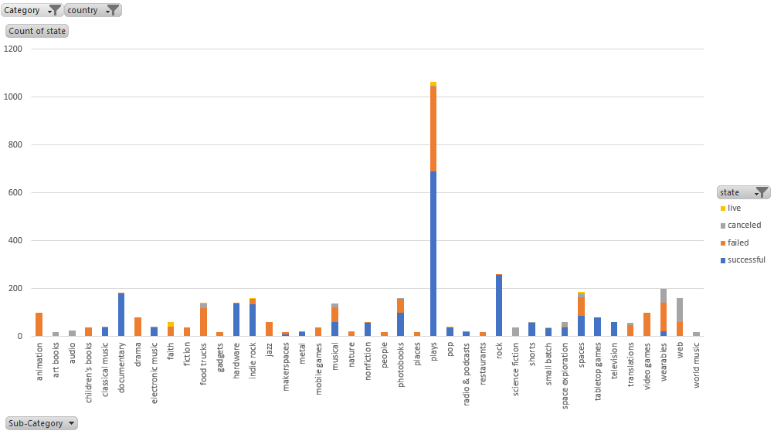

In the sub-category chart you will see that theater only has one prevailing sub-category; plays. Whereas all other categories have more comparable data.

**Possible Tables and Graphs**

The tables below demonstrate how narrowing the data can give a more accurate portrayal of the information given.

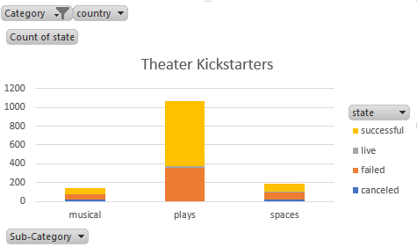 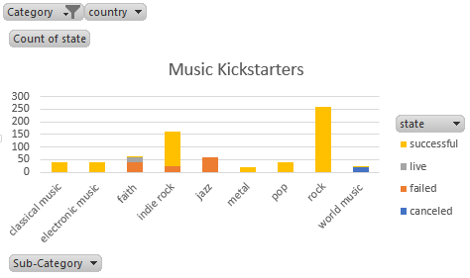

After On the left graph, we eliminated all other categories, leaving only theater, we can see that the sub-category, plays should be broken down further or eliminated from the data all together. The music chart on the other hand offers a more varied dataset and more useable information.